AVENUE REAL ESTATE APPLICATION

INTRODUCTION

Avenue is an android based application platform that is designed to allow people to access real estate services such as buying, renting and selling of houses, offices and other estates, In a convenient, fast and reliable way. This application will be working and managing people’s data. For instance, with exception of the admin and seller, in addition to first name, surname, phone number, email and password information that will be provided at the registration time and later, clients or the customers will have to provide their residence’s location. The location helps in prioritizing listing properties in ascending order starting with properties that are closer to their location and ending with properties from far. In addition, based on customers wish list, the app will be able to keep track of customer’s activities and browsing behaviors on the app. This will help us to provide even better services because next time a customer logs in, properties related to properties in the wish list will appear first. This will help customers to find what they are looking for even before searching or scrolling up and down on the app.

INTERFACE DESIGN OF THE APPLICATION

1. SPLASH SCREEN

When a user installs Avenue application on their Android mobile device and tries to run it, the first page that shows on the screen once they open the application is a splash screen. The use of this splash screen is to create a picture to the user of what he/she is to expect and the standard logo on the middle of the screen beeps repetitively.



1. ONBOARD SCREEN

After the splash screen loads what comes next is an on-board slide page which describes what our application will do. Of which the first one asks a user if they are looking to buy a home and that our platform can help them choose one of the best houses that are available for sale. The second splash screen only outlines houses for sell and the last splash screen describes how the application will help you in finding a house or apartments that are available for renting or buying. On each page of the splash screen there is a skip button which takes you straight to the next age if one is not interested in getting to know what the platform does. on the last slash screen there is a “Get Started” button which takes the user to a register account age. 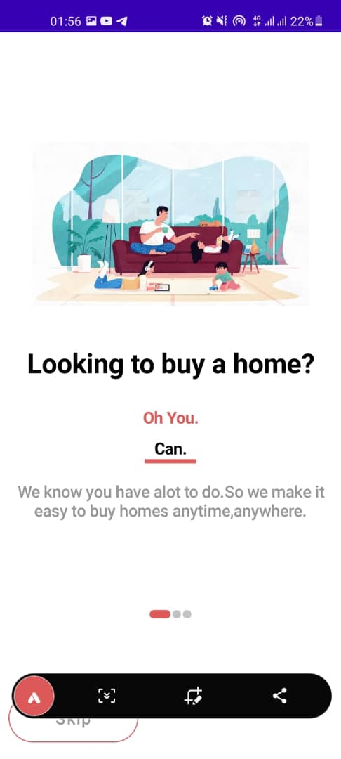 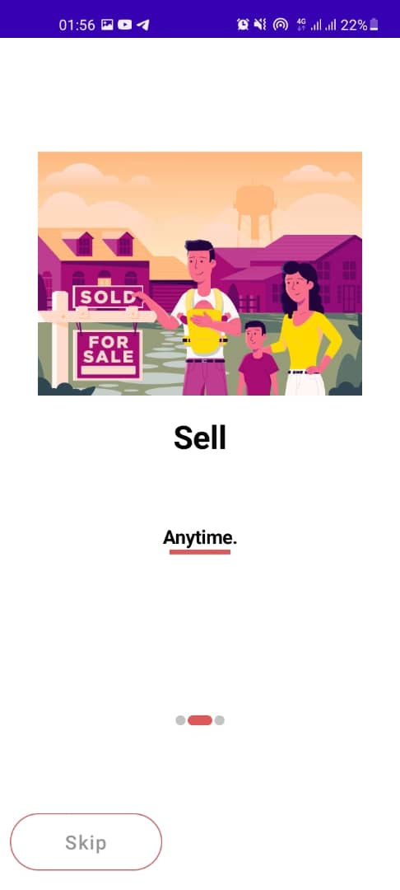 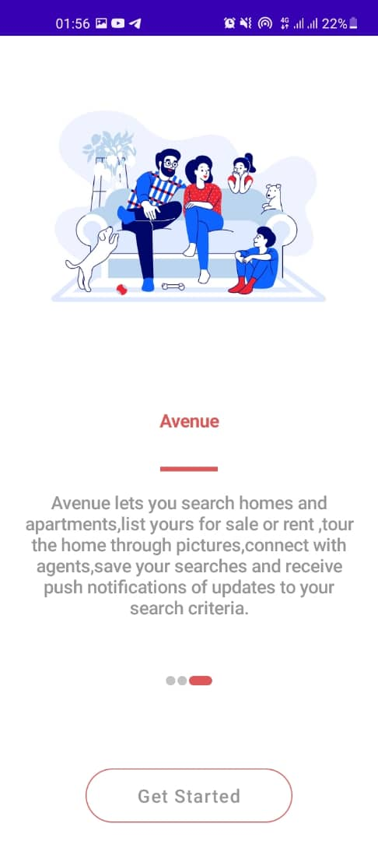

1. REGISTER ACCOUNT SCREEN

On the Register account screen there are different tabs that allow a user to enter their details thus email address, password and confirm password tab. After the user enters these details they click the button click which takes them to the Complete Profile screen.

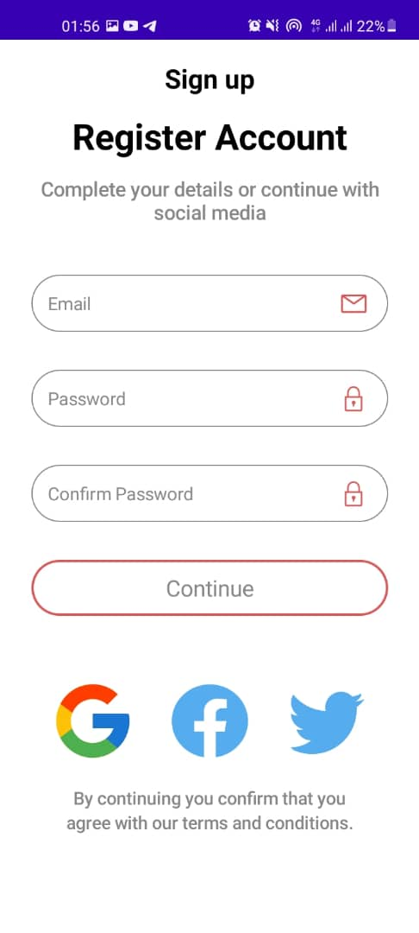

1. COMPLETE PROFILE SCREEN

On this page, one is supposed to fill the profile as shown above by putting your personal details. After all the details one will be requested to submit the form by clicking continue which takes you to the next page.

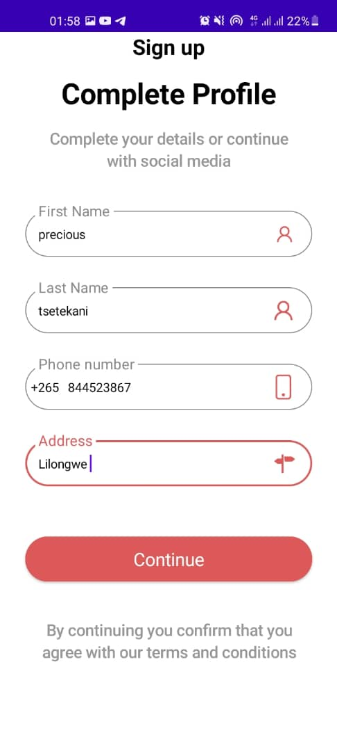

1. SUCCEED PAGE

This page tells the user that the account has been well created, when you tap continue you are taken to the other page where you can now sell nor buy your products.

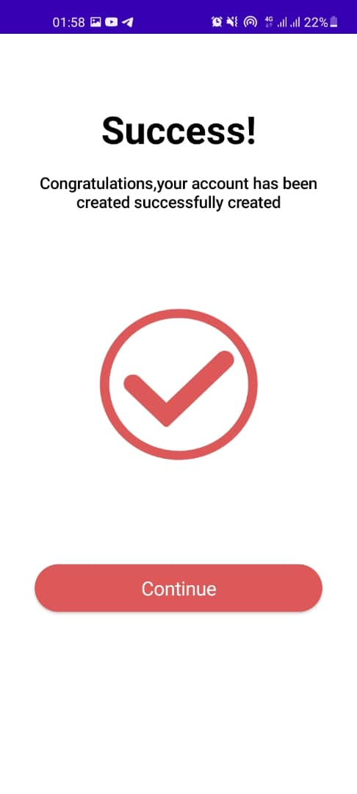

1. THE HOME PAGE

This page contains all the available resources that the tenants are offering. It has got latest listings meaning things that have just been uploaded. On top is a search button where one can just search the property that is of need. There is location and distance codes to show the property’s location and how far the property is from your current location. It is on home page that you can upload your photos of your business.

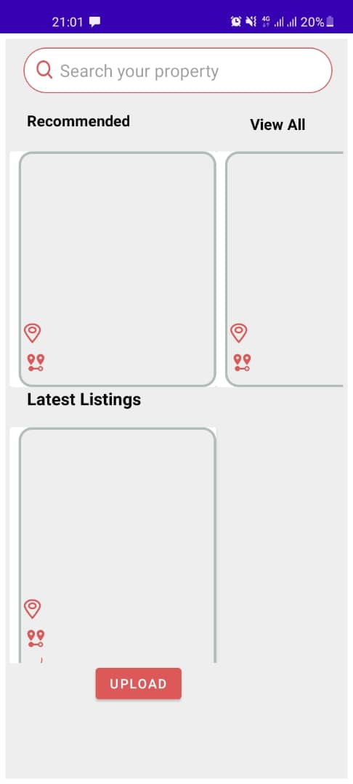

1. UPLOAD PAGE

On this page you enter all the speciation’s of your product on the following page.

Product Name, Number of rooms, Location, Product price and Description.

The red part is called

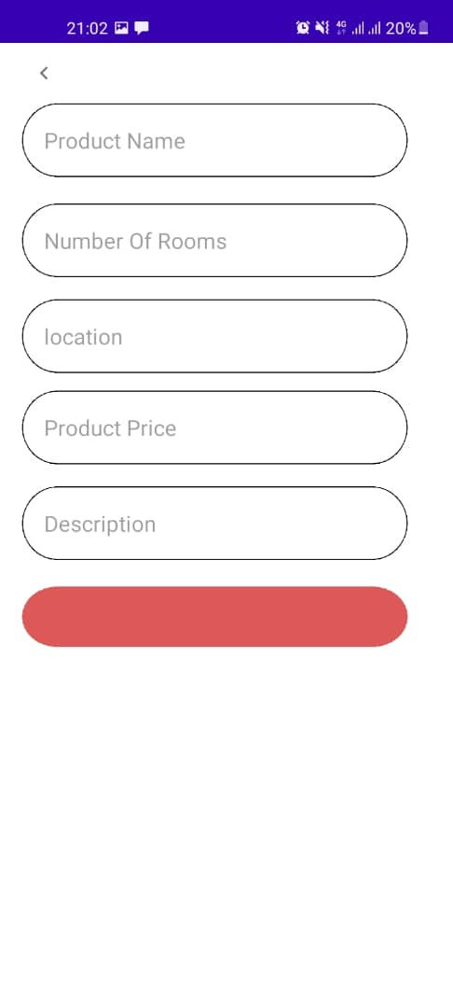

1. VIEWING PAGE

On this page you are able to view all the properties that people have, after viewing you tap continue.

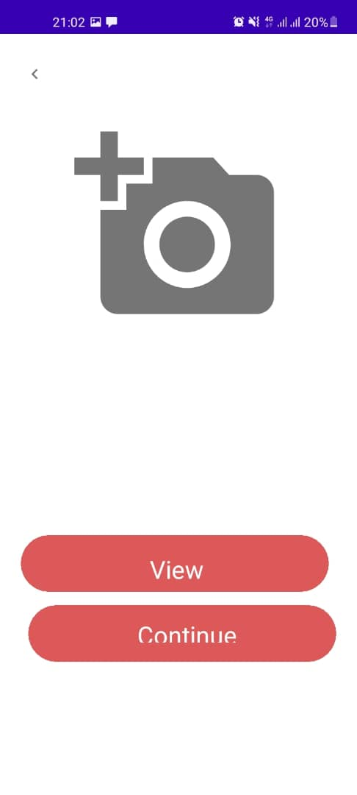 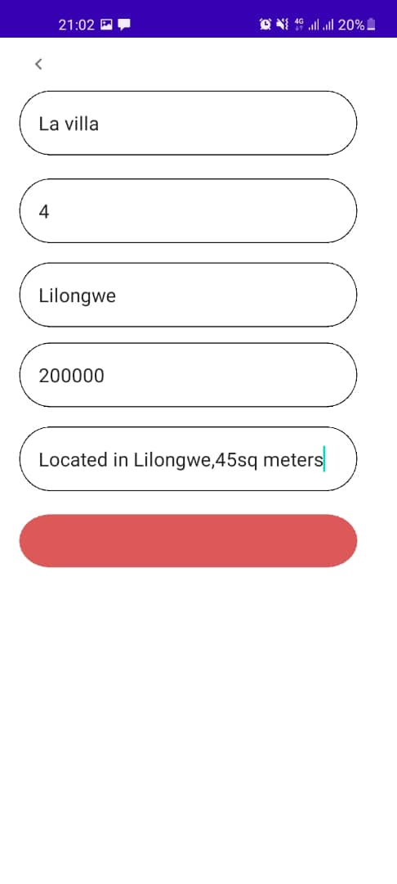s